Yealink T46G

Quick reference Guide

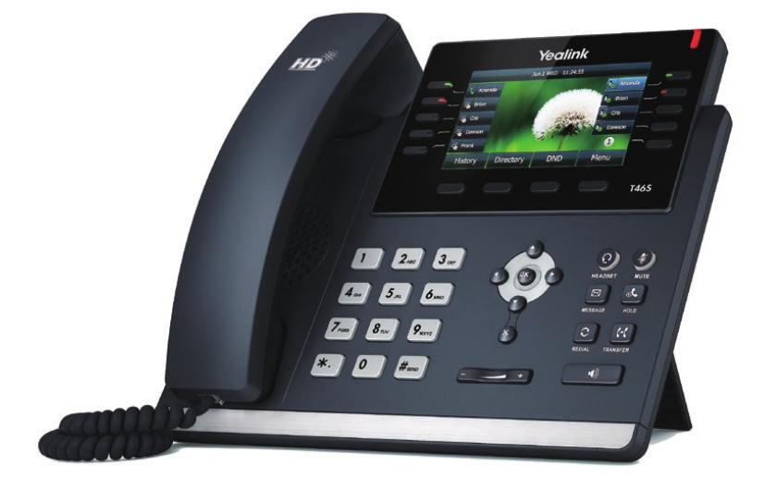

Make a Call:
- Lift handset and dial an internal number, EG. Dial extn 101.
- Lift handset and dial an external number. Remember to hit 9 first to get an outside line.
Make a second call while on a call:
Put the 1st call on HOLD, then dial the 2nd number. Dial 9 for an outside number.

Conference call:
While on a call place that call on HOLD. Dial the 2nd number and then click on CONFERENCE via the options menu.

Handel a Call
Hold/Retrieve: Click the HOLD key
Transfer: Place the 1st call on HOLD, Dial the 2nd number and then click TRANSFER in the menu
Park/Unpark: Click the PARK key

Forwarding Calls:
Forward all calls: Click the PBX key+Call Forward+Forward All Calls+Select User/Contact/Voicemail/Number you want to forward the calls to.
Forward No Answer: Click the PBX key+Call Forward+Forward N0 Answer+Select User/Contact/Voicemail/Number you want to forward the calls to.
Forward On Busy: Click the PBX key+Call Forward+Forward On Busy+Select User/Contact/Voicemail/Number you want to forward the calls to.
Forward No Registration: Click the PBX key+Call Forward+Forward No Registration+Select User/Contact/Voicemail/Number you want to forward the calls to.

Voicemail:
To access your Voicemails, click the Message Key

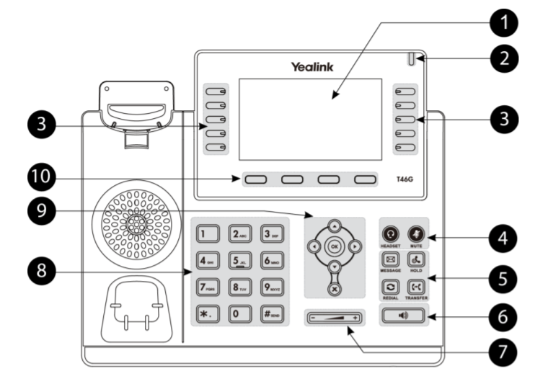

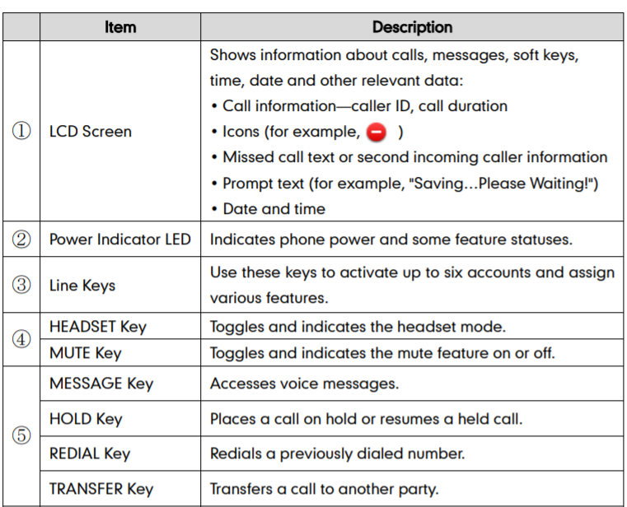
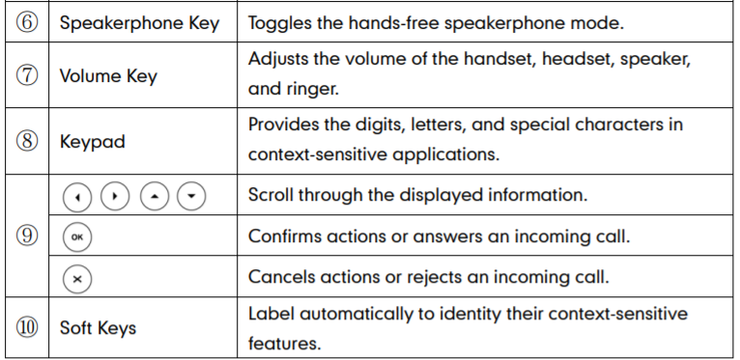

For more user guides and How To videos please go to https://www.magnetplus.ie/business/support/

If you need any additional assistance or have any queries, please contact: Magnet Talk Support: 1800 789 789
Email: support@magneplus.ie

