Yealink T31 Quick reference Guide

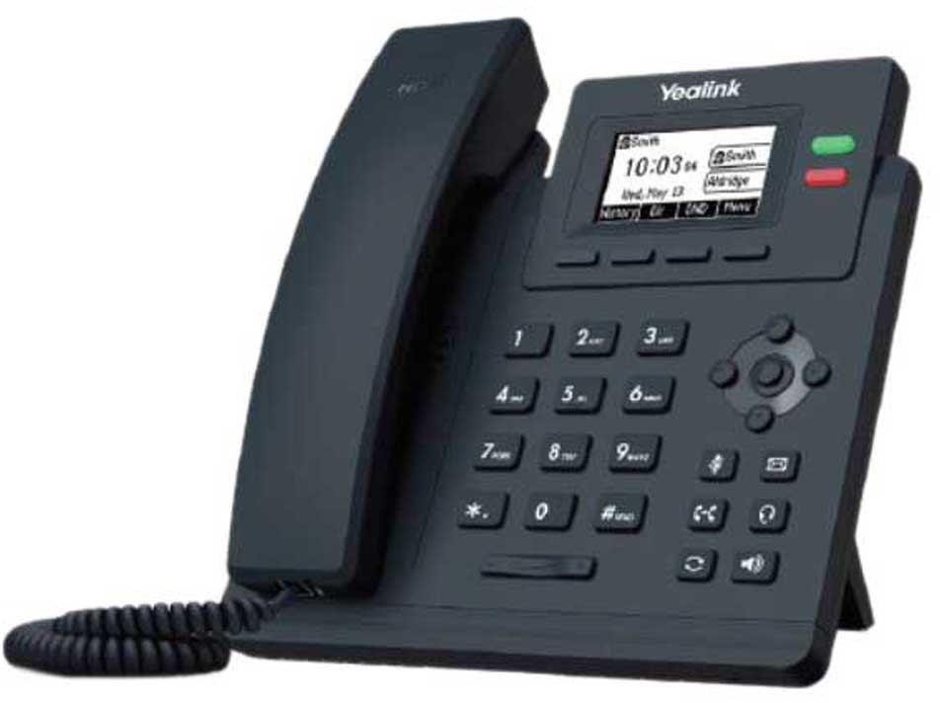

Make a Call:
- Lift handset and dial an internal number, EG. Dial extn 101.
- Lift handset and dial an external number. Remember to hit 9 first to get an outside line.
Make a second call while on a call:
Put the 1st call on HOLD, then dial the 2nd number. Dial 9 for an outside number.

Conference call:
While on a call place that call on HOLD. Dial the 2nd number and then click on CONFERENCE via the options menu.

Handel a Call
Hold/Retrieve: Click the HOLD key
Transfer: Place the 1st call on HOLD, Dial the 2nd number and then click TRANSFER in the menu
Park/Unpark: Click the PARK key

Forwarding Calls:
Forward all calls: Click the PBX key+Call Forward+Forward All Calls+Select User/Contact/Voicemail/Number you want to forward the calls to.
Forward No Answer: Click the PBX key+Call Forward+Forward N0 Answer+Select User/Contact/Voicemail/Number you want to forward the calls to.
Forward On Busy: Click the PBX key+Call Forward+Forward On Busy+Select User/Contact/Voicemail/Number you want to forward the calls to.
Forward No Registration: Click the PBX key+Call Forward+Forward No Registration+Select User/Contact/Voicemail/Number you want to forward the calls to.

Voicemail:
To access your Voicemails, click the Message Key

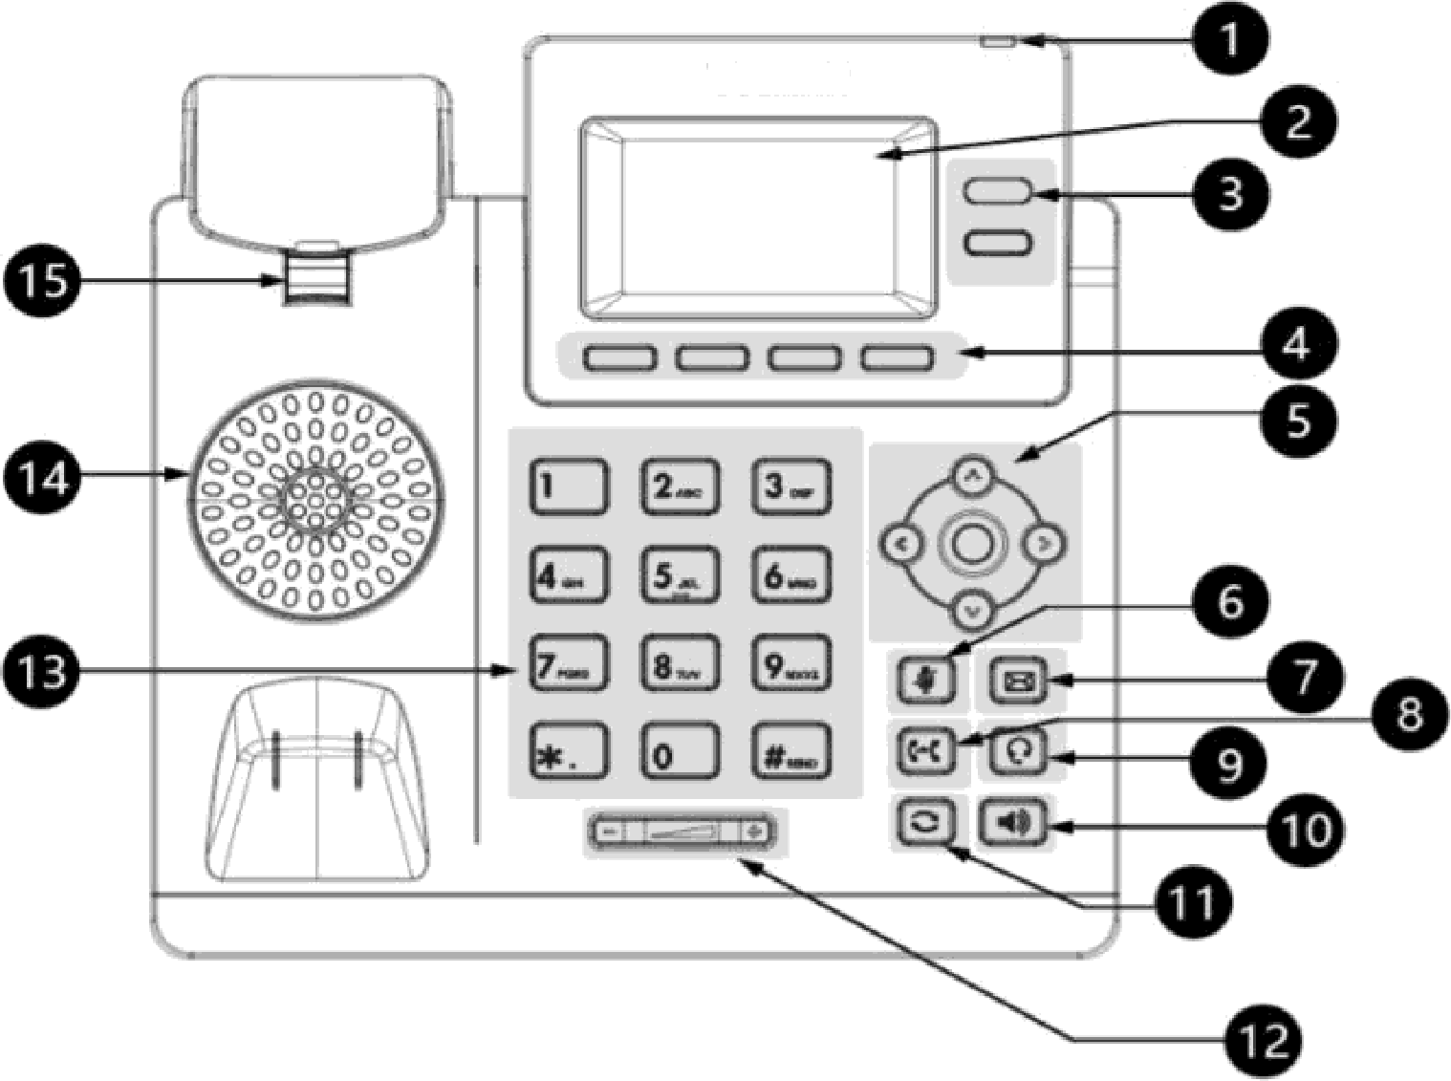

NO. | Bern | Description
 | Pawar LED Indic-  ator | Indicates call status, message status and phona 's system status.
2 | Phone Screen | Shows information about your phona, such as calls, messages. soft keys, lima and date.
3 | Line Keys | AccBss your phona li nes and features.  Tha T30P/T30 phona does not hav6 Line keys.
4 | Soft Keys | AccesG the function displayed on the screen above the soft keys. The soft keys change depending on what you are doing at th s time.
5 | Navigation Keys | - Scroll through infarmatan or opbons displayed on the screen  - Access History and Directory FBSP8ctively.
 | OK Key | Confirms actions or answers incoming calls.
6 | MUTE Key | Toggles the microphone on or off.
7 | MESSAGE Key | Accesses your voice messages.
B | TRAN Key | Transfers a call
g | HEADSET Key | Toggles the headset mode on ar off.
10 | Spaakarphons Key | Toggles the speakerphons (hands-free) mode or not.
11 | REDIAL Key | Redials a previously dialed number.

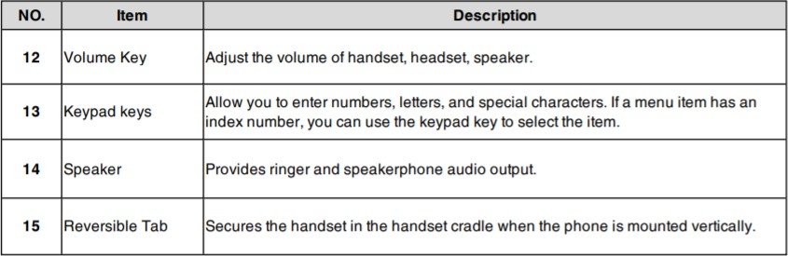

For more user guides and How To videos please go to https://www.magnetplus.ie/business/talk-support/

If you need any additional assistance or have any queries, please contact:
Magnet Talk Support: 1800 789 789 Email: support@magnetplus.ie

