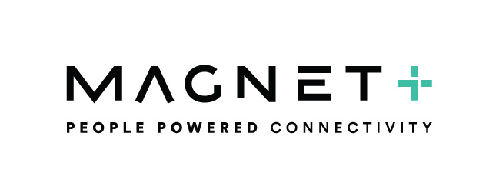

User Portal Guide

User Portal Icons

You can log into your individual user portal with the details set to you in your welcome email.

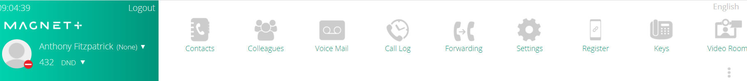

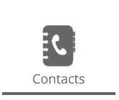
This is your Contacts icon. Here you will find all of your personal contacts, all of your common contacts and your extension list.

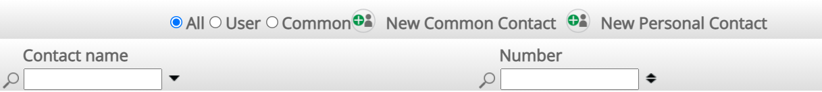

You can use the above tool bar to sort by All contacts, Users, Common Contacts and personal contacts. You can also click on the New Personal Contact Icon to add a new contact to your contact list. Adding a new contact in the portal will update all of your contact lists on your softphone, mobile app and deskphone.

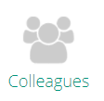
This is your Colleagues Icon. From here you can see all the users on you phone system. You can call or instant chat any user on your PBX from this screen by clicking on the phone icon beside their name.

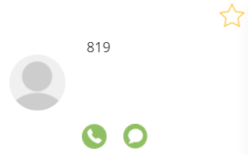

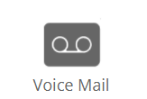

This is your voicemail icon. Here you will see your voicemails and any recorded calls. You will also see your voicemail options. You can callback, save the contact details and download the voicemail.

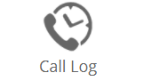

This is your call log icon. Here you can see your call history. All of you incoming, outgoing, and missed calls will be displayed and can be easily sorted by clicking the option at the top of the screen.

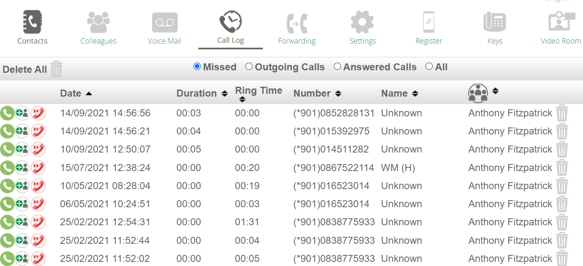

You can call the number or add as a contact by clicking the icons on the left of the call log screen.

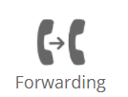

This is your call forwarding Icon. Click on the dropdown menu for each of the 4 options to forward your calls as needed. Simply click on the dropdown and choose where you want your calls to go. You can choose from another user, a hunt group, a contact from your contacts list or send your calls directly to voicemail.

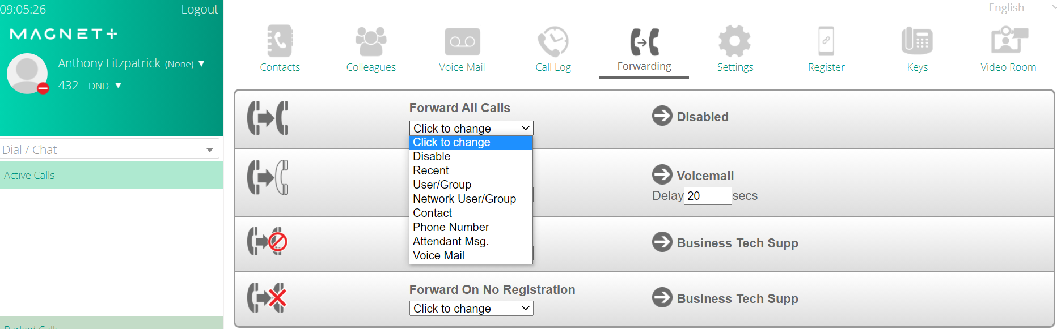

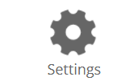

This is your settings Icon. From this screen you can enable/disable phone features such as voicemail forwarding keypad tones and show/hide your outgoing number. You can click a feature on or off by clicking the icon for each function.
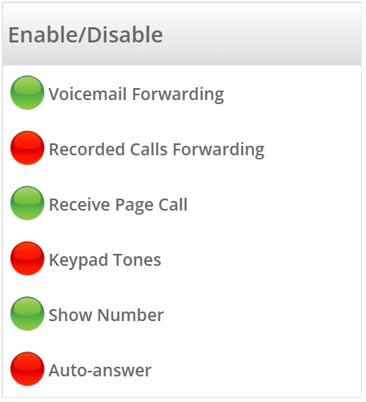

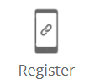

This is your Smartphone Registration icon. When setting up your Magnet Talk Smartphone App you will be asked to enter a pairing code when installing the app on your smartphone. To get the pairing code simply click on the Register icon and this will generate your pairing code. Enter the pairing code when prompted on your smartphone devise to register.

See blow example:

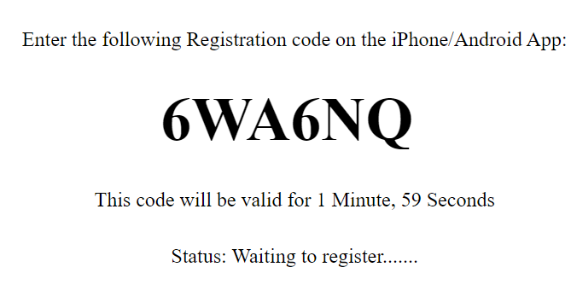
Please note this is an example and the above code cannot be used to pair your App.

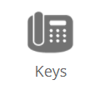

This is your Function Key Icon. Here you can choose the short cut keys to be displayed on your softphone or desk phone. Click on the arrow beside the key number to assign a function, user, contact from your address and many other useful short cut keys.
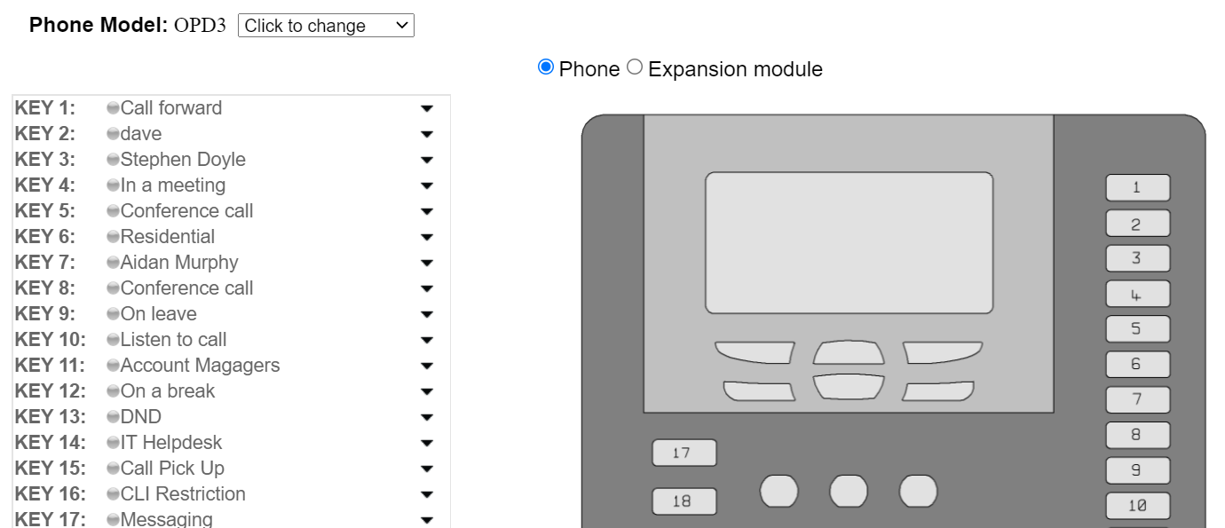

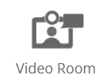

This is the video room Icon. Here you can create and join video conference calls. To create a room, you will need to enter a video room name. You can add a password if needed and then click on the create icon.

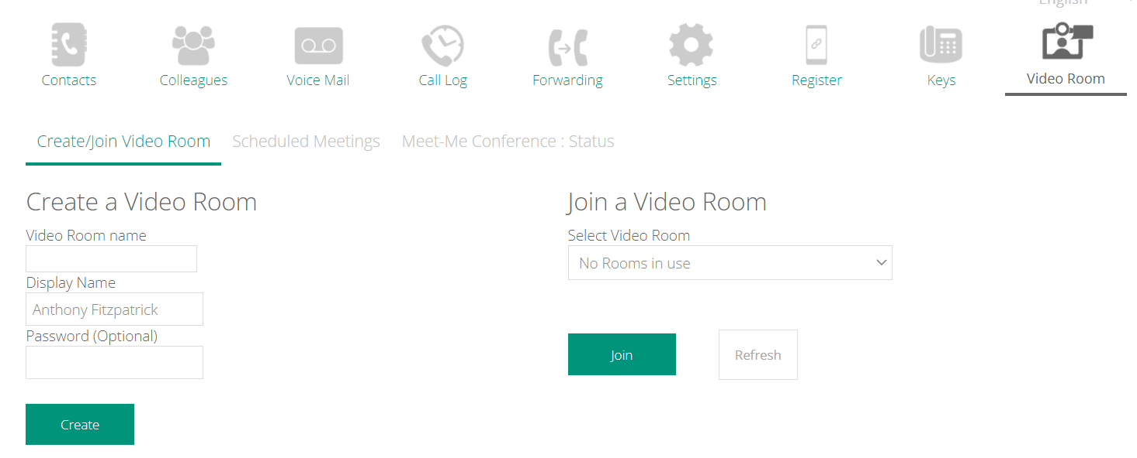

This will create the video room and allow you to share link with anyone you want to join the video call.

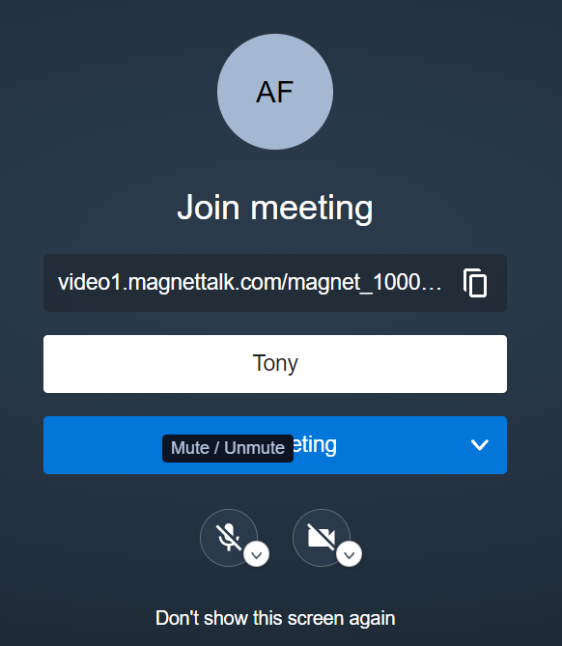

Click the Scheduled Meetings tab to reserve a meeting room for a specific date and time.
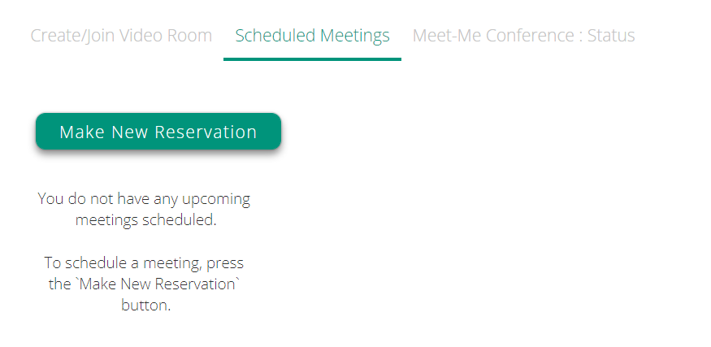

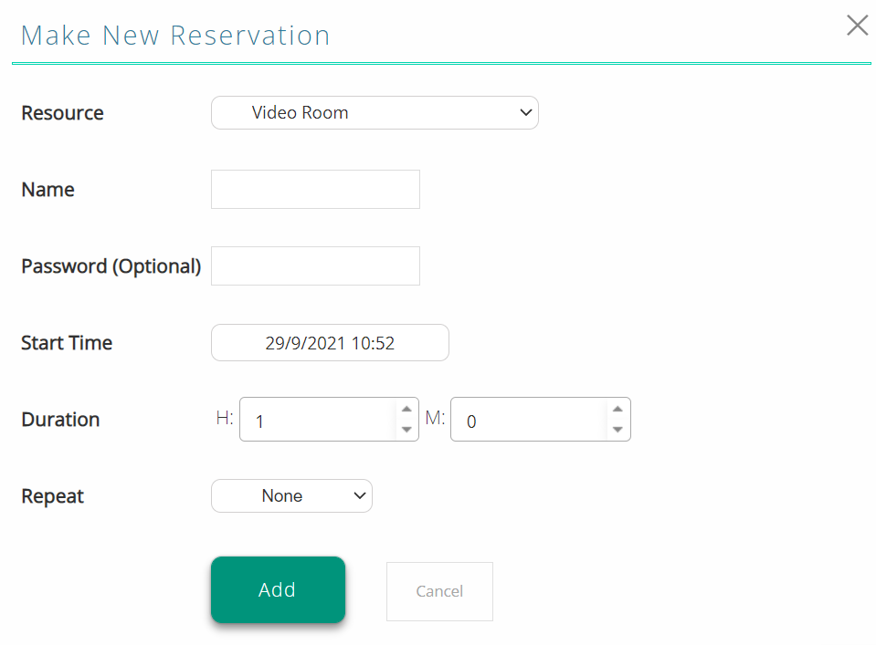

User Portal Side Bar

On the left of your screen, you will see the User Portal side bar. This allows you to see active calls, Parked calls and Pick Up call fields.

From these fields you can answer calls by clicking on the phone icon.

You can easily transfer a call by clicking on an active call and then dragging and dropping its into another user’s profile on the colleagues tab.

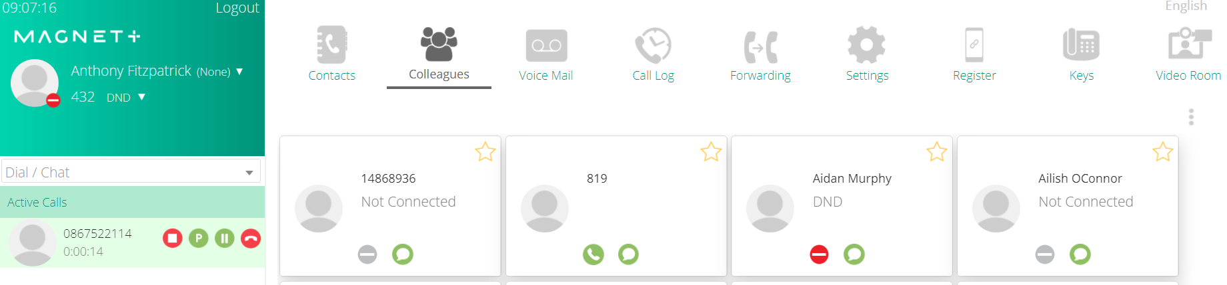

By clicking on the arrow under your user profile you can select your status from the options below as needed or you can create your own status by populating the field at the bottom of the list.

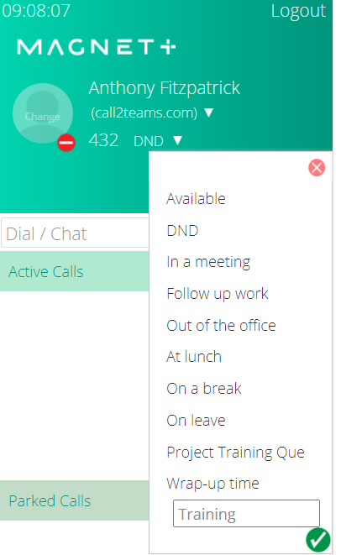

Add a profile picture by clicking on the profile icon in the top left toolbar.
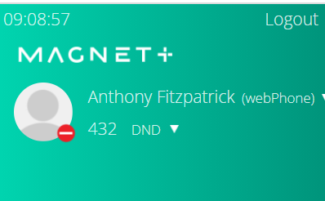

more information and help can be found at:
https://www.magnetnetworks.com/business/downloads/
https://www.magnetnetworks.com/business/userguides/
https://www.magnetnetworks.com/business/videos/

If you need any additional assistance or have any queries please contact:
Magnet Talk Support: 1800 789 789
Email: support@magnetplus.ie

