Set up Voice Mail

Softphone

To set up voicemail simply click on the menus option and by using the navigation keys click down to mailbox settings.

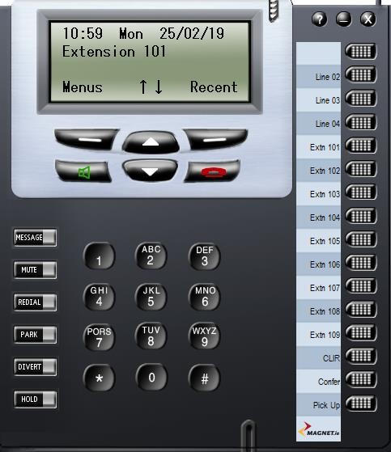
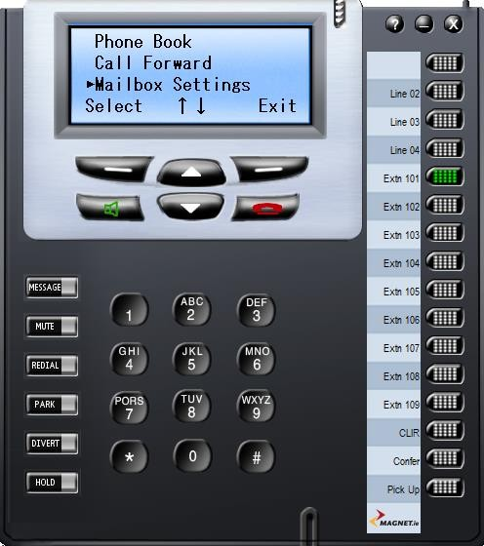

Choose to select then use the navigation keys school down to set up voicemail, then choose select. Within your setup voicemail, you then have 2 options.

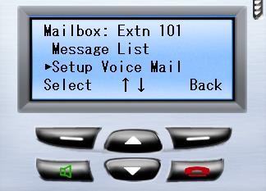

The 1st option is an intro message. This is the standard voicemail greeting that any calls coming to your phone will receive.

The 2nd option you will see is the busy message. This is a message a caller will here when they call you and you are already on a call.
You can follow the same process for both options once you click on the required voicemail type.

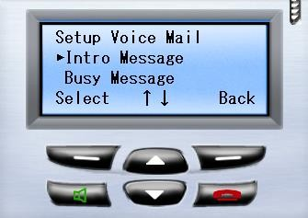

To activate the intro or busy message, click on the select key. From here, you will have 3 options.

1, You can choose to play a previous voicemail recording that you may have already set up.

2, You can record a new one

3, You can delete an existing recording

To set up a new record using the navigation key click on record, here you will see that you have the option to record a standard voicemail message.

When you click on the record option, you will see that the timer on the screen will start to move. This will be when you will begin to record your voicemail greeting. When you have finished simply click on stop. Your voicemail recording is now automatically put in place.

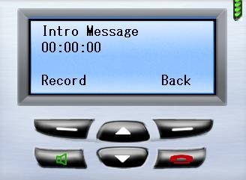

Yealink Phones

If you are using a Yealink phone provide by Magnet + simply click on the PBX soft key on the display screen of the phone. Use the navigation keys to scroll through the menu until you get to Voicemail. Click OK. Go to Setup Voicemail and click OK. You will be presented with the same options.

The 1st option is an intro message. This is the standard voicemail greeting that any calls coming to your phone will receive.

The 2nd option you will see is the busy message. This is a message a caller will here when they call you and you are already on a call.

Follow the same process as before to set up your Intro or Busy message.
If you need extra assistance, please contact:
Magnet Talk Support: 1800 789 789
Email:
support@magnetplus.ie

