How To Set Up Remote Users

Intro

This Document will cover the basics of Magnet Talk Softphone and App installation. It will give an overview of the platform, a Softphone user guide and links to How to Videos.

Contents
Intro 2
Installing your Magnet Talk Windows PC Softphone ..3
Installing Your Magnet Talk Mobile App 7
Installing Your Magnet Talk Mobile App 8
Magnet Talk Chrome Extension 9
Soft Phone User Guide 11
How To Videos 11

Installing Softphone

In order for you to make and receive calls, you will need to download the Magnet Talk softphone on your laptop, PC or tablet.
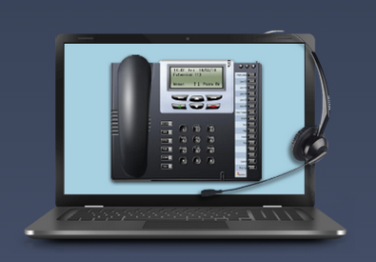

To install your Windows PC Softphone download the application by clicking on the below link:
Softphone Download

Simply click the Softphone file in the top left of the screen and select Finish from the following pop up. Both highlighted in red below.

Step 1

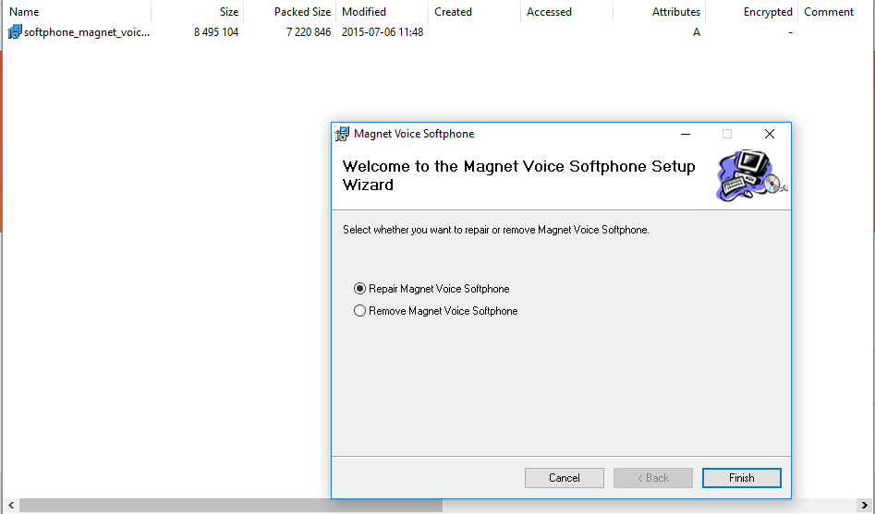
Step 2

Follow the Softphone wizard install steps that will be displayed to you.

User guides for your new Magnet Talk Softphone or physical desk phone can be found by clicking on the below link:

User Guides

Once installed you will need to enter your IP Reg Name and Reg Pin. Your Magnet Talk Administrator can access these details in the Users tab of the admin portal under IP Phone Registration. Keep these details stored for your records. You will need them in the future when adding the Magnet Talk Chrome extension and when registering your Magnet Talk App to your smart phone.

To add your IP details to your Softphone,
Open the Softphone on your screen. Once downloaded you will see the Magnet + softphone Icon displayed on your devise on either your desktop or you can search for Magnet Talk by using your devices search facility.

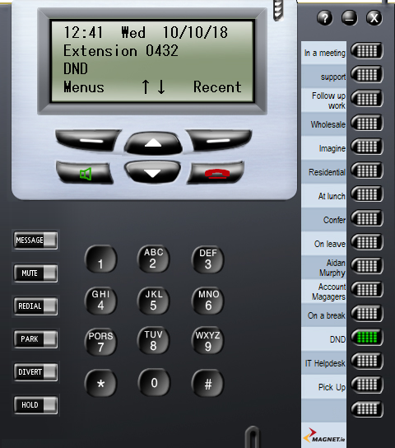
Right Click to add Reg details

Right click on the grey outline of the soft phone and go to settings from the pop up window.

Enter the Server IP, your Reg Name and Reg Pin as assigned to you by your Magnet Talk Administrator.

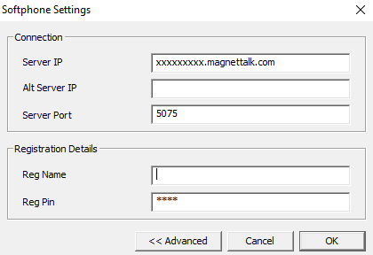

Enter your Server IP Enter your Reg Name Enter your Reg Pin

- Server IP
- Reg Name
- Reg Pin
To be provided to you by your Magnet Talk Administrator.

Did you know that Magnet Talk is also available as an App for your smart phone? Having the Magnet Talk App installed on your phone will allow you to make and take phone calls directly from your extension and is always available, anytime, anywhere – yes anywhere, in the office, on the road, at home, in Ireland in fact anywhere in the world! Helping you Work Wherever, Whenever!
friendly App for agents who do not need access to higher level features.

Installing the Magnet Talk Mobile App

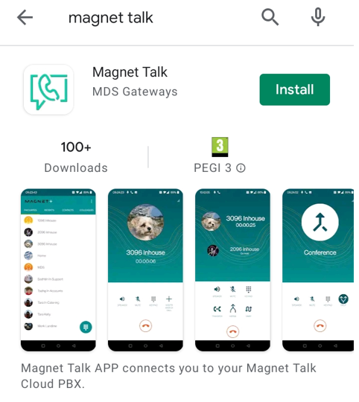

To install your Magnet Talk mobile app go to your iOS App Store or Android Play Store and search for “Magnet Talk”, or alternatively you click on the link below

Magnet Talk App

To configure your Magnet Talk app please follow the Magnet Talk Android App Installation or the Magnet Talk iOS App Installation guides by following this URL:

User Guides

Installing the Magnet Talk Mobile App

To install your Magnet Talk mobile app go to your iOS App Store or Android Play Store and search for “Magnet Talk”

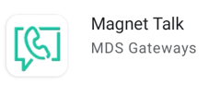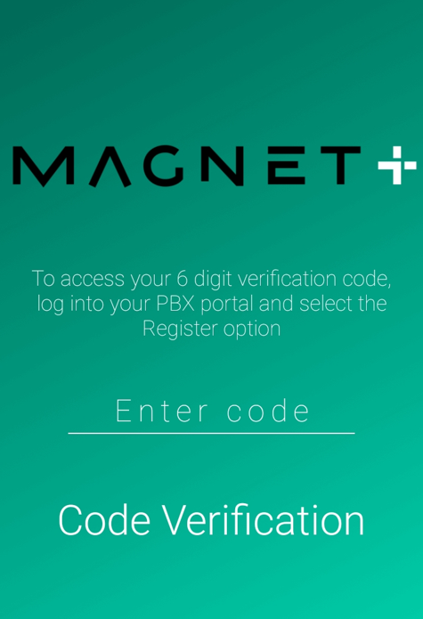

Once the app has been downloarded, open the app and you will be asked to enter a Pairing Code.

This code is available on your indevidual user portal by clicking on the Pair Smartphone App icon

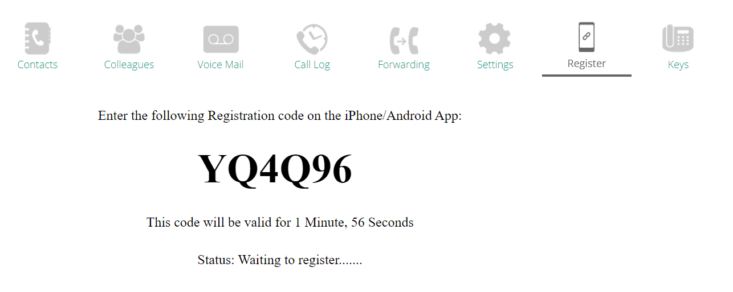

You will then be given an automatically generated Pairing Code to enter in the App on your phone. The code will only be valid for 2 minutes so if this times out please click the Pair Smartphone App icon again to generate a new code.

Magnet Talk Chrome Extension

The Magnet Talk Chrome Extension gives you soft phone functionality from your chrome browser. The Magnet Talk Chrome extension allows you click to dial functionality on your desktop. There are bubble notifications that pop to your desktop telling you that someone is calling you or if you have missed a call or received a voicemail.
These features along with the ability to access your Magnet Talk portal from the extension and the ability to make calls to your phonebook make this extension a productive and necessary extension.

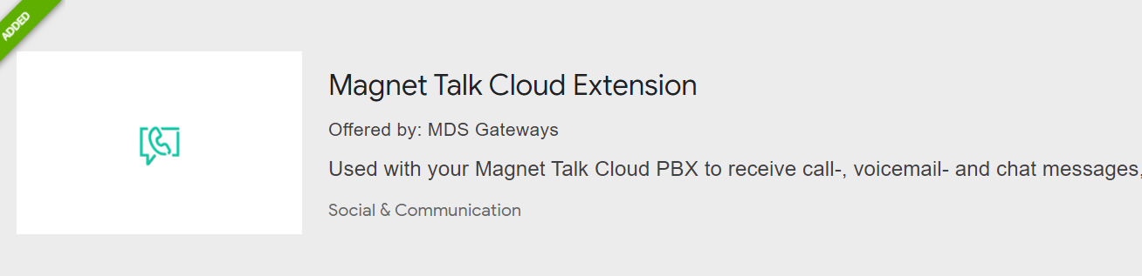

Go to the chrome web store and search for Magnet Talk extension or you can follow the below link,

Magnet Talk Cloud Extension

Once you’ve found the extension click the “add to chrome button”.

You will then need to enter Server Address, IP Reg details and user pin.

How to Register your Magnet Talk Cloud Extension
The below is to be provided to you by your Magnet Talk Administrator:

Server IP Reg Name Reg Pin

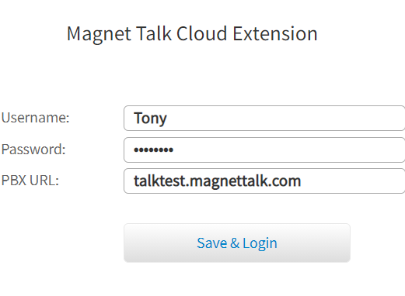
Softphone user guide can be found on our support page
Click the below link:

Soft Phone User Guide

Extra support information can be found at:
User Guides

Click here

How To Videos
For helpful how-to video: Click Here
Additional features can also be found at www.magnetplus.ie

LIVECHAT
You can also contact us via our LiveChat @ our website magnetplus.ie
Chat to an agent straight away and get answers to your questions easily and quickly.

