Magnet Talk IOS Mobile App

Installing the Magnet Talk Mobile App

To install your Magnet Talk mobile app go to your iOS App Store and search for “Magnet Talk”

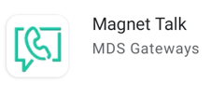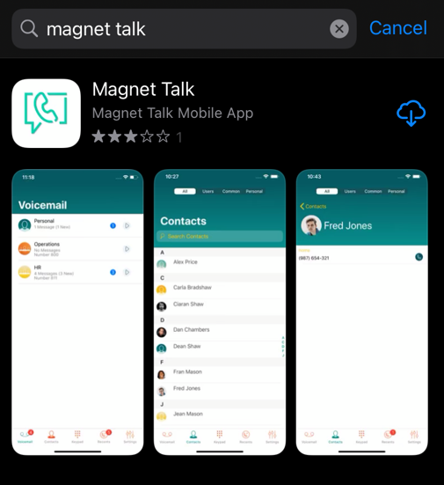

Once the app has been downloarded, open the app and you will be asked to enter a Pairing Code.

This code is available on your indevidual user portal by clicking on the Pair Smartphone App icon

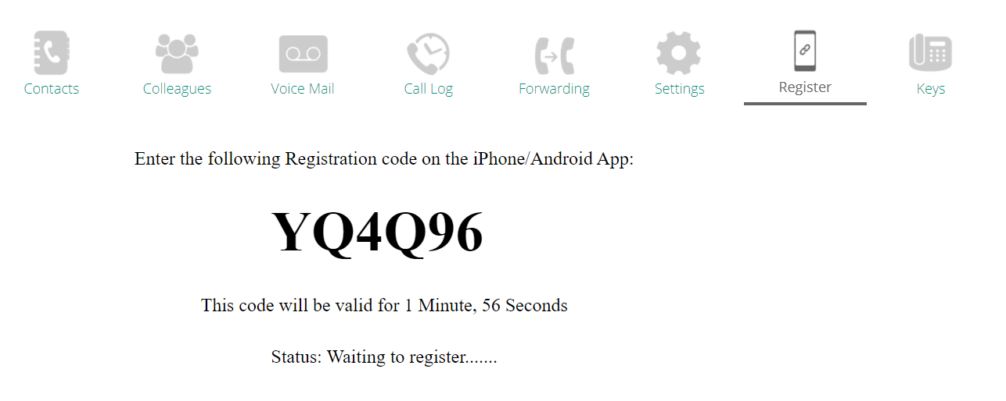

You will then be given an automatically generated Pairing Code to enter in the App on your phone. The code will only be valid for 2 minutes so if this times out please click the Pair Smartphone App icon again to generate a new code.

Once activated you will be able to make and receive calls using your extension and any calls that come into any hunt group your extension is included in.
From the user menu, you can see all internal users on your PBX System. Click on the user to dial.

When you open the App on your Smart Phone you will see the below home page where you can access all your All Contacts/Users/ Common Contacts and Personal.

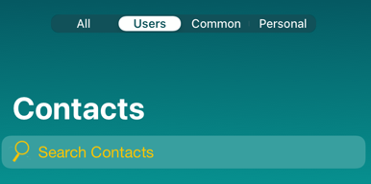

To access your voicemails, click on the voicemail icon at the bottom of the screen

To make a call simply dial the external number or internal extension number and then click on the dial icon.
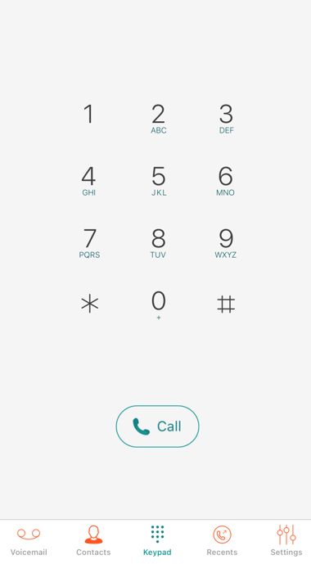

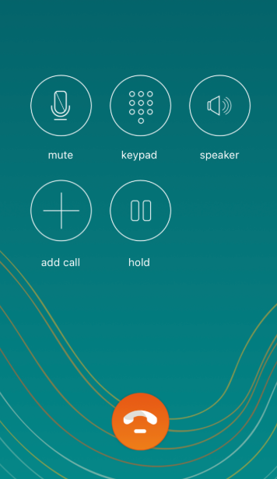
While on a call you will see the function keys below the call display screen.
- Speaker: Click this icon to switch to loudspeaker
- Mute: Click this key to mute and unmute the call
- Keypad: Click this Icon to access the keypad if you want to make a second call
- Add/Transfer Call: While on a call you can add another person to the call as a 3-way conference call or you can transfer the call to another user or contact from your address book

Transferring a call
While on a call click on the Add/Transfer Call icon

The original call will be automatically placed on hold allowing you to choose from your Favourites/Recents/Contacts and Colleagues.

Dial the contact you want to transfer the call to. You will then see both calls on screen.
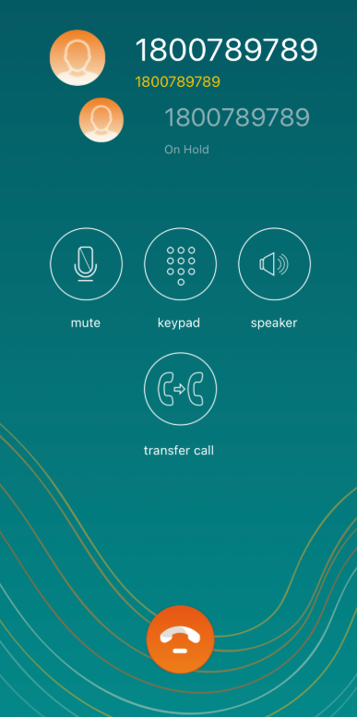
To transfer the call, click on the Transfer Key

To access your App Settings click on the 3 dots in the top right corner of the contacts screen.

Settings
- Show Number: This allows you to hide your direct dial number on outgoing calls
- Ring Tone: Change the ring tone of the App
- DND: Enable Do Not Disturb
- Call Forward: Forward all of your incoming calls to another user, contact from your address book or send your calls directly to voicemail
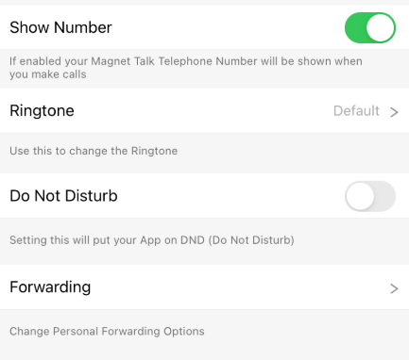

If you need any additional assistance or have any queries please contact:
Magnet Talk Support: 1800 789 789 Email: support@magnetplus.ie

