VMG8623 Set Up Guide

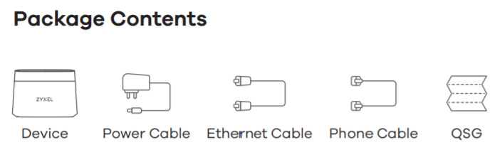

Step 1: Connect the yellow ethernet cable provided in the box to the blue port marked WAN at the back of your router and connect the other end to the Magnet Networks data point on your wall.
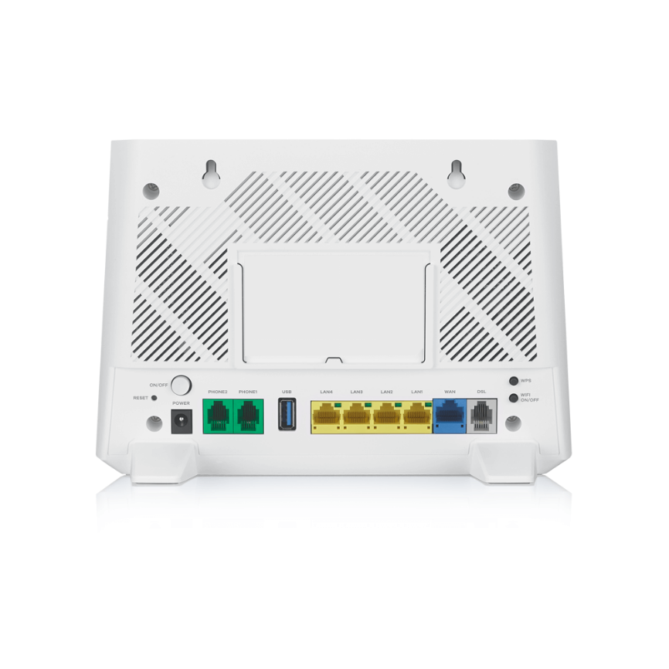

Step 2: Connect the power cable provided in the box to the power input at the back of the router. If you have phone service with Magnet Networks, connect your phone to the PHONE1 port.

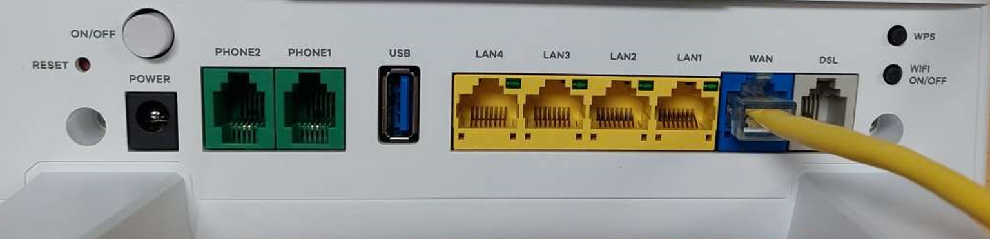
Power
Phone

Step 3: Make sure your router is powered on. There is a power on/off button at the back of your router beside the power cable.

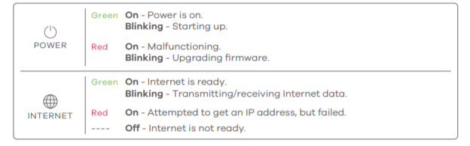

Step 4: Use your device to search for your wireless network SSID and enter your password. This info can be found on the back of the router.
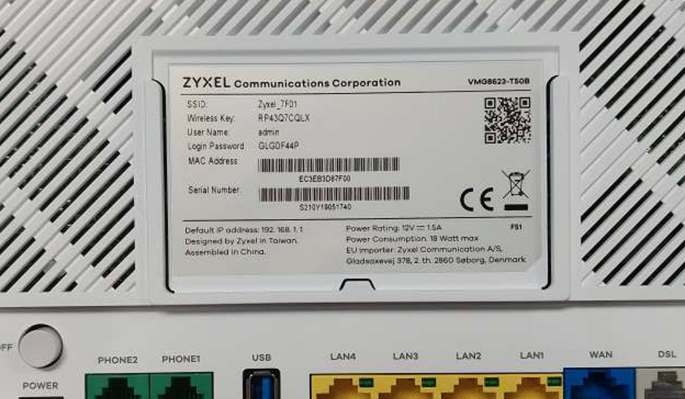

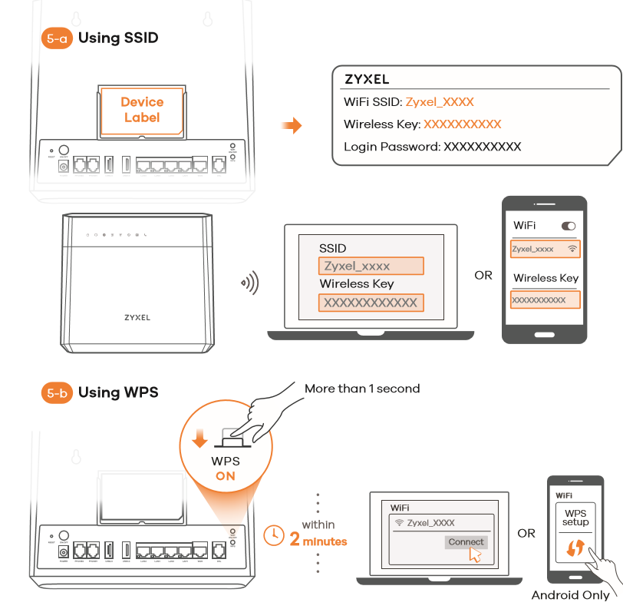

To log into your router, open a web browser and go to http://192.168.1.1. Enter the default Username (admin) and admin Login Password (on the device label), and then click Login. The Wizard runs. Follow the Wizard prompts to complete the setup.

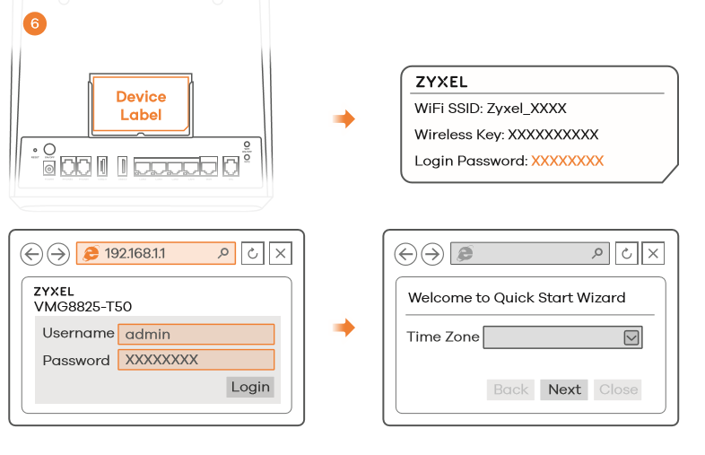

Please do not reset your router as this will result in loss of service.

FAQ

From time to time your broadband services can stop working or can be intermittent……
There are 4 main reasons for this…and all very easy for you to check and resolve quickly
1. Loose or faulty connections or cables…. have you checked all your cables and connections to your router?
2. The router from time to time needs to be re-booted as it has gone off line, or it may have gone faulty…..have you checked your router set-up?
3. The line into your premises is disconnected or has a break in it somewhere along the route to your house or apartment….if you live in an apartment have you checked with your property management company that there is no issue with cabling in your building?
4. Lastly…have you ever had connectivity? Have you received confirmation by e-mail and SMS that your services are active?

Where to Find Your Wireless Password / WEP Key
Your Password/Wi-Fi Key for your Magnet router is located on a sticker on the bottom of your router.
Your Wireless Password / WEP Key or Network Key will also be on that same sticker.

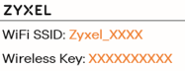

limited or no connectivity

When attempting to set up or make network connections on a Windows computer, you may encounter a Limited Or No Connectivity error message similar to the following: Limited or no connectivity: The connection has limited or no connectivity. You might be unable to access the Internet or some network resources.

This message can result from any of several different technical glitches or configuration problems. Follow these steps to resolve Limited Or No Connectivity errors in Windows.
If your computer connects to the network directly via the Magnet router, resetting (powering off and on) the router may resolve the issue. If not using a broadband router, or if resetting your router only temporarily resolves the issue and the error message re-appears later, continue to the following steps.

If directly connected to your network using an Ethernet cable, your cable may have failed. Temporarily replace your network cable with a new one to determine whether this resolves the issue.

If connecting to your network using Wi-Fi it may be that you are too far from the Wi-Fi Access point or there is interference affecting the signal from the Wi-Fi access point. Try moving closer to the Wi-Fi access point to get a better signal.

If connecting to your network using Wi-Fi and using wireless security, your WEP or other security key may not be set properly. Check the wireless security configuration on your computer’s network adapter and update if it necessary.

My Broadband/Internet Service is Slow

Before you trouble shoot it is worth remembering that the Internet is an unregulated collection of computers. Magnet provides the initial connection from your home to the Internet – but we have no control over what happens beyond our network.
During times of significant internet usage, good (major broadcast events), and bad (large scale internet attacks), etc) the Internet itself may be slow.
In some instances, a specific site you are trying to visit may be having difficulties due to high visitor numbers.
With some broadband providers there is the additional complication that you may be sharing your connection to the internet with other customers. That is not the case with Magnet +.

If you need extra assistance, please contact:
Magnet Voice Support: 1800 789 789
Email: support@magnetplus.ie

